# Grants Pass Sustainable Energy Dashboard Data Maintenance Guide

This guide documents the on-going process for maintaining the input data stream used to support the sustainable energy dashboard for the City of Grants Pass. It describes the folder structure for organizing the various files, the process steps for converting data received from the various energy utilities, the expected format of the received files, and instructions for maintaining supporting and calculation constants files used by the dashboard calculation program.

## Process Overview

Data files are currently received from three different “utilities” when requested by city staff. Data on solid waste is prepared by city staff from billing statements generated by the two solid waste disposal companies currently contracted by the city.

|  |  |  |
| --- | --- | --- |
| **Source** | **File Description** | **How Provided** |
| Pacific Power | Electricity consumption for each electrical meter per billing period (month). | Excel spreadsheet created by utility customer services upon request. |
| Avista | Natural gas consumption for each gas meter per billing period (month). | Excel spreadsheet created by utility customer services upon request. |
| Pacific Pride | Vehicle fueling events for a time period showing vehicle ID, date of fueling event, gallons of fuel, and price per gallon. | Extracted by city staff from a city operated system upon request. |
| Republic | Solid waste disposal data including bill month / year, disposal container volume and frequency of pickup, and amount billed. | Prepared by city staff from bills submitted by the utility. |
| Southern Oregon Sanitation | Solid waste disposal data including bill month / year, disposal container volume and frequency of pickup, and amount billed. | Prepared by city staff from bills submitted by the utility. |

Upon receipt of a data file from a source, the data provided is first manually reviewed to ensure that it is in the expected format, exported from an Excel spreadsheet format to a Comma Separated Values (CSV) format, and placed in the expected input folder. If necessary, minor manual changes may be necessary so that the file is in the expected format.

Except for solid waste data, a program (Python script) is executed to convert the data to a simplified structure and to add required data specific to each utility meter, address location, or vehicle (for example, the city operation or sub-operation associated with the meter or vehicle is added to each data line). This program will also check to ensure that supporting information is available for each meter or vehicle appearing in the input file (for example, if a new meter has been added for which no supporting information has been listed). A warning is also provided if no information has been received for any meter or vehicle (to help detect incomplete information provided by the utility).

Upon successful conversion, the converted data is placed by city staff in the “permanent” folder location for the specific source utility.

Supporting information regarding each meter, address, and vehicle as well as calculation “constants” are stored in files organized in a master reference folder. These files can be updated by city staff as needed as changes occur (new utility meters activated, new vehicles procured, or changes to supporting calculation values are released by agencies such as the federal Environmental Protection Agency (EPA)). Documentation and instructions for updating these files are provided in this guide.

Whenever needed, a dashboard data calculation program (Python script) can be executed. This program reads the data from the permanent folders and supporting data from the master reference folder, calculates greenhouse gas emissions values, and summarizes the data by year-month, city operation and sub-operation, and emissions source (electricity, natural gas, gasoline, diesel, solid waste, water restoration, and forest sequestration offset). The output data file is then published by city staff to the expected locations for city staff use in analysis or to the city website for public dashboard display.

The process overview is pictured on the following diagram.



## Folder Structure

The various data files used by the process are organized under a Base folder location as described below.

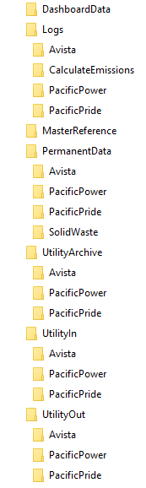DashboardData

Contains the final output dashboard data file ready for publication to city staff and the public dashboard website location.

Logs

Location for temporary log files produced by the utility data conversion programs or the dashboard data calculation program. There is a subfolder for each utility data source and for the dashboard emissions calculation program (“CalculateEmissions” folder). The logs provide information about the program progress, input files processed, and any errors or warnings that occurred. Log files can be removed by city staff when no longer needed / wanted.

MasterReference

Holds the description files for meters and vehicles used by the dashboard calculation program. The folder also includes reference files used by the program for calculating emissions from gasoline, diesel, electricity, solid waste, water restoration processes, and forest sequestration offsets. A file also provides the changeable assumptions used to estimate emissions from employee commutes.

PermanentData

Files that have been converted by the utility input conversion process are permanently stored in this folder under the subfolder for the associated utility that provided the data. Once copied to this location, data will typically not need to be modified or removed. **Care must be taken to avoid placing duplicate or overlapping data from the same source in this folder, because an overcount of emissions and costs will result.**

UtilityArchive

This folder location is meant to keep the original data files as provided by utilities for reference if and when needed. It has a subfolder for each utility / data source. It is not used directly by any program.

UtilityIn

Each data conversion program will read and process and combine all files placed in the subfolder associated with its source. **Once successfully processed, files in this folder should be moved to the appropriate archive folder for the utility source.**

UtilityOut

Each data conversion program will write the converted and consolidated data file associated with its utility source in the subfolder provided here. The output file will be given a standardized file name based on the source and the year and month range read from the input file. This will simplify identifying any duplicated, overlapping or missing input data time periods. **Once produced and verified, the files in this location should be moved to the appropriate subfolder for the source under the PermanentData folder.**

## Running Program Scripts

Computer program scripts (written in the Python programming language) have been prepared to perform the data normalization for data files received by utilities and to generate the dashboard data file from the utility data files. These are the four Python programs shown in red on the process overview diagram.

To run the scripts, open a Windows File Explorer and locate the folder in which the Python programs have been installed. The folder contents will include the following files:

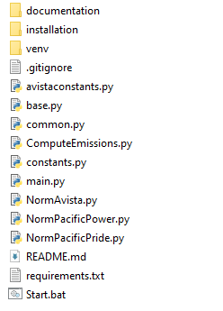

Double click on the Start.bat file. A window will be opened that displays the selection menu for running the Python program scripts.

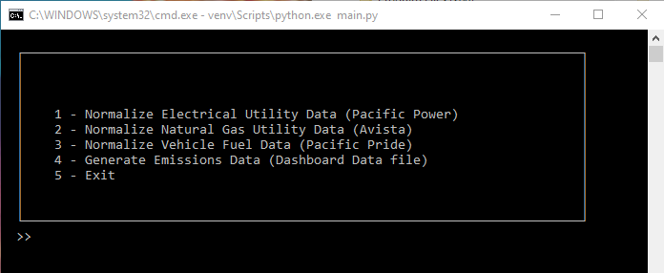

Type the number from the menu corresponding to the program to be run (the number will appear after the >> prompt on the window) and press the Enter key. The associated program will be run and if executed normally the menu will appear again waiting for the next choice. When all desired programs have been run, enter 5 at the prompt, press the Enter key, and close the window by clicking on the X in the upper right corner of the window.

The full process steps associated with each of the programs in the menu are described in detail in the following sections.

## Process Instruction – Data Normalization for Pacific Power (Electricity)

This process step takes the Excel data file(s) provided by Pacific Power customer service and converts it to the “normalized” (standard and simplified) format expected by the dashboard calculation program. This section provides the detailed steps that need to be followed to complete this part of the process.

Step 1: Review provided data format.

City staff should open the received file to ensure that it is in the expected format. The name of the file is unimportant as far as the conversion program, but should be unique among all received files and be descriptive enough to aid staff in understanding which utility the file is for (Pacific Power) and the time period covered by the file.

The file must have one header line that describes the columns in the file as the first line and no total line at the end of the file. Blank rows will be ignored. **The exact names that are given to each column in the header line are not important as long as the data in each column is in the expected order**. The data conversion program uses the order of the columns rather than the name of the column in the header line.

Column A – Customer ID as assigned by the utility. Not used for the dashboard.

Column B – Account Sequence as assigned by the utility. Not used for the dashboard.

Column C – Agreement Sequence as assigned by the utility. Not used for the dashboard.

Column D – Customer Name. Typically “CITY OF GRANTS PASS”. Not used for the dashboard.

Column E – Address. Some versions of the file do not repeat duplicate values on rows after the first data line for that address. Not used for the dashboard, but may be useful in helping to identify information for new electric meters.

Column F – City State Zip Code. Some versions of the file do not repeat duplicate values on rows after the first line for the same address. Not used for the dashboard.

Column G – Meter Number. This field is required. If no value is provided for a given data row in the file, that row will be skipped by the conversion program. Each meter number in the file should have a corresponding entry in the reference file PacificPowerMaster.csv. See the process instruction for Maintain Electrical Meter Information for instructions for maintaining this file.

Column H – Year Month. This field is required. The billing year and month in the format YYYYMM, where YYYY is the four-digit year (example: 2023) and MM is the numerical two-digit month number (example: 01 for January, 12 for December). A leading zero for the month number is expected.

Column I – Number of days. This field is read by the conversion program but is not currently used in calculations.

Column J – On Peak Period Kilowatt Hours. Not used for the dashboard.

Column K – Off Peak Period Kilowatt Hours. Not used for the dashboard.

Column L – Kilowatt Hours Usage. This field is required. Rows that do not have a value in this column will be skipped by the conversion program. Commas separating digits will be removed by the program.

Column M – On Peak Period Kilowatts. Not used for the dashboard.

Column N – Off Peak Period Kilowatts. Not used for the dashboard.

Column O – Kilowatt Usage. Not used for the dashboard.

Column P – KVAR Usage. Not used for the dashboard.

Column Q – Invoice. This field is required. Leading dollar signs and commas separating digits will be removed by the program.

Step 2: Export as a CSV file.

In Microsoft Excel, select the File menu, then the Export option. In the dialog presented, select the Change File Type option. Under the Other File Types section, select the CSV (Comma delimited)(*.csv) option. Click the Save As button. Browse for the UtilityIn / PacificPower folder and save the exported file in that location.

Step 3: Run the conversion program.

Follow the instructions under the “Running Program Scripts” section of this guide and select option 1 from the menu. The program progress will be briefly shown as in the example below and the option menu will again be shown when the script has successfully finished. Note that the display may refresh very quickly. Follow the next step to verify the script log file to ensure the script has completed.

D:\Task Force\GPDash>python NormPacificPower.py

Processing now. Log file D:\Task Force\Dashboard\Base\Logs\PacificPower\Log 2023-07-05 T 105220.txt

Processing complete

Step 4: Review the log file in the Logs / PacificPower folder.

The file name is shown as output of the conversion program output, and is in the format Log YYYY-MM-DD T HHMMSS.txt, where YYYY-MM-DD is today’s date and HHMMSS is the time that the program was executed.

The log will show the file name of the meter master file used and how many meters had references in the file. The log will show the name of each input file processed from the UtilityIn / PacificPower folder, the number of input rows read (including the header row), the number of output rows written, and the number of rows with no meter number for each file.

The log will also list the meter numbers that have no description entries in the MasterReference / PacificPowerMaster.csv file (new meters), and will list meters that did not have any data in the input file (informational, and can happen if meters become inactive / obsolete).

Step 5: Add entries for any missing meters in the MasterReference / PacificPowerMaster.csv file, if needed.

If the log shows missing meter entries from the Pacific Power master reference file, follow the instructions for Maintain Electrical Meter Information later in this guide. If entries were added, repeat these instructions from Step 3.

Step 6: Move files to their permanent locations.

Move the file generated by the conversion program from the UtilityOut / PacificPower folder to the PermanentData / PacificPower folder. This file will have the standard naming structure “PacificPower YYYY MM.csv” or “PacificPower YYYY MM to YYYY MM.csv” if the input file(s) include multiple months of data, where YYYY is the four-digit year and MM is the two-digit month number based on the contents of the data.

In this step**, it is important to confirm that the resulting output data file does not duplicate or overlap years and months from files that are already in the PermanentData / PacificPower folde**r. This can easily be determined by looking at the file names of the existing and new file. If duplication or overlap occurs, remove the new output file from the Permanent Data / PacificPower folder, remove duplicate data rows from the input file(s) in the UtilityIn / PacificPower folder using Microsoft Excel, and repeat this process from Step 3. There should also not be gaps in the year and month time periods covered by the data files, which would indicate missing data from the source utility.

Move the file(s) from the UtilityIn / PacificPower folder to the folder UtilityArchive / PacificPower in case it is needed for reference, investigation, or audit.

Step 7: Check and clear folders.

Check to ensure that the UtilityIn / PacificPower folder, UtilityOut / PacificPower folders are now empty.

Any files in the Logs / PacificPower folder can be removed if desired, or older files removed if log files are to be retained for reference for some period.

## Process Instruction – Data Normalization for Avista (Natural Gas)

This process step takes the Excel data file(s) provided by Avista customer service and converts it to the “normalized” (standard and simplified) format expected by the dashboard calculation program. This section provides the detailed steps that need to be followed to complete this part of the process.

Step 1: Review provided data format.

City staff should open the received file to ensure that it is in the expected format. The name of the file is unimportant as far as the conversion program, but should be unique among all received files and be descriptive enough to aid staff in understanding which utility the file is for (Avista) and the time period covered by the file.

The file has the following structure:

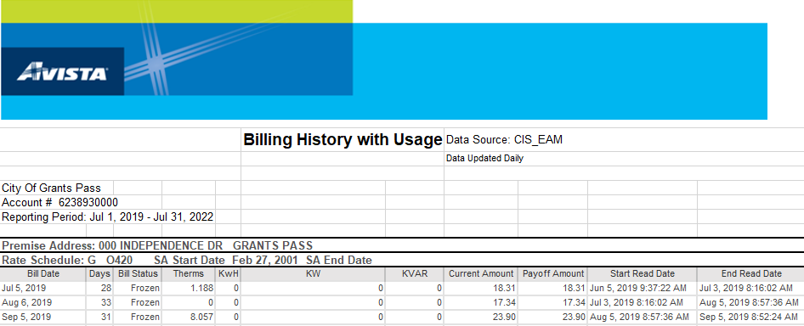

The header section of the file has the Avista logo, information on the source of the file, the customer name and account number, and the reporting period covered by the file.

The file then has repeating sections, one for each address. The section heading has one row with the Premise Address and one showing the Rate Schedule. The address is required for matching against the master reference file for Avista located in the MasterReference / AvistaMaster.csv file.

Following the address and rate schedule lines, there is a column heading line describing the contents of each following row in the section. The names of the columns are not important, but the order of the column content is critical and is assumed to be as follows by the conversion program.

Column A – Bill Date. This column is not actually used by the dashboard, because the content is not consistently only date information (some rows also include meter numbers or other information).

Column B – Days. This column is not used by the dashboard.

Column C – Bill Status. This column is not used by the dashboard.

Column D – Therms. This field is required. Commas separating digits will be removed by the program.

Column E – Kilowatt Hours. This column is not used by the dashboard.

Column F – Kilowatts. This column is not used by the dashboard.

Column G – KVAR. This column is not used by the dashboard.

Column H – Current Amount. This field is required. Commas separating digits will be removed by the program.

Column I – Payoff Amount. This column is not used by the dashboard.

Column J – Start Read Date. This column is not used by the dashboard.

Column K – End Read Date. This field is required. It is used by the conversion program to determine the year / month associated with the data row. This column is used instead of Column A – Bill Date because it is consistently formatted as a date-time value.

The detail data lines for the address are followed by a single subtotal line before the data for the next address appears. This row will be ignored by the conversion program.

The end of the file has a row showing a report page number and run date, followed by blank rows and a row with “Internal Use Only”. These rows are ignored by the conversion program.

Step 2: Export as a CSV file.

In Microsoft Excel, select the File menu, then the Export option. In the dialog presented, select the Change File Type option. Under the Other File Types section, select the CSV (Comma delimited)(*.csv) option. Click the Save As button. Browse for the UtilityIn / Avista folder and save the exported file in that location.

Step 3: Run the conversion program.

Follow the instructions under the “Running Program Scripts” section of this guide and select option 2 from the menu. The program progress will be briefly shown as in the example below and the option menu will again be shown when the script has successfully finished. Note that the display may refresh very quickly. Follow the next step to verify the script log file to ensure the script has completed.

D:\Task Force\GPDash>python NormAvista.py

Processing now. Log file D:\Task Force\Dashboard\Base\Logs\Avista\Log 2023-07-05 T 111504.txt

Processing complete

Step 4: Review the log file in the Logs / Avista folder.

The file name is shown as output of the conversion program output, and is in the format Log YYYY-MM-DD T HHMMSS.txt, where YYYY-MM-DD is today’s date and HHMMSS is the time that the program was executed.

The log will show the file name of the address master file used and how many addresses had references in the file. The log will show the name of each input file processed from the UtilityIn / Avista folder, the number of input rows read (including the header rows), and the number of output rows written.

The log will also list the addresses that have no description entries in the MasterReference / Avista.csv file (new addresses), and will list addresses that did not have any data in the input file (informational, and can happen if addresses become inactive / obsolete).

Step 5: Add entries for any missing meters in the MasterReference / Avista.csv file, if needed.

If the log shows missing address entries from the Avista master reference file, follow the instructions for Maintain Gas Meter Information later in this guide. If entries were added, repeat these instructions from Step 3.

Step 6: Move files to their permanent locations.

Move the file generated by the conversion program from the UtilityOut / Avista folder to the PermanentData / Avista folder. This file will have the standard naming structure “Avista YYYY MM.csv” or “Avista YYYY MM to YYYY MM.csv” if the input file(s) include multiple months of data, where YYYY is the four-digit year and MM is the two-digit month number based on the contents of the data.

In this step**, it is important to confirm that the resulting output data file does not duplicate or overlap years and months from files that are already in the PermanentData / Avista folde**r. This can easily be determined by looking at the file names of the existing and new file. If duplication or overlap occurs, remove the new output file from the Permanent Data / Avista folder, remove duplicate data rows from the input file(s) in the UtilityIn / Avista folder using Microsoft Excel, and repeat this process from Step 3. There should also not be gaps in the year and month time periods covered by the data files, which would indicate missing data from the source utility.

Move the file(s) from the UtilityIn / Avista folder to the folder UtilityArchive / Avista in case it is needed for reference, investigation, or audit.

Step 7: Check and clear folders.

Check to ensure that the UtilityIn / Avista folder, UtilityOut / Avista folders are now empty.

Any files in the Logs / Avista folder can be removed if desired, or older files removed if log files are to be retained for reference for some period.

## Process Instruction – Data Normalization for Vehicle Fuel (Gasoline and Diesel)

This process step takes the Excel data file(s) provided by city staff from an internal database upon request and converts it to the “normalized” (standard and simplified) format expected by the dashboard calculation program. This section provides the detailed steps that need to be followed to complete this part of the process.

Step 1: Review provided data format.

City staff should open the received file to ensure that it is in the expected format. The name of the file is unimportant as far as the conversion program, but should be unique among all received files and be descriptive enough to aid staff in understanding which utility the file is for (PacificPride) and the time period covered by the file.

The file must have one header line that describes the columns in the file as the first line. Any line beginning with the label “Grand Total” or any blank rows will be ignored. **The exact names that are given to each column in the header line are not important as long as the data in each column is in the expected order**. The data conversion program uses the order of the columns rather than the name of the column in the header line.

Column A – Vehicle ID. This is the unique identifier assigned to each vehicle by city staff. This field is required. Each vehicle ID must appear in the reference file MasterReference / VehiclesMaster.csv. See the process instruction for Maintain Vehicle Master Information for instructions for maintaining this file.

Column B – Date. The date on which the fueling event occurred. This field is required. It should be in the format m/d/yyyy, where m is the month number, d is the day number within the month, and yyyy is the four-digit year. Leading zeros for the month and day values are not required. The slash character “/” between month, day, and year is required.

Column C – Gallons. The gallons of fuel consumed during the fueling event. This field is required. It may or may not have a decimal point or decimal places.

Column D – Price. The price charged per gallon during the fueling event. This field is required. Any dollar signs will be removed by the conversion program.

Step 2: Export as a CSV file.

In Microsoft Excel, select the File menu, then the Export option. In the dialog presented, select the Change File Type option. Under the Other File Types section, select the CSV (Comma delimited)(*.csv) option. Click the Save As button. Browse for the UtilityIn / PacificPride folder and save the exported file in that location.

Step 3: Run the conversion program.

Follow the instructions under the “Running Program Scripts” section of this guide and select option 3 from the menu. The program progress will be briefly shown as in the example below and the option menu will again be shown when the script has successfully finished. Note that the display may refresh very quickly. Follow the next step to verify the script log file to ensure the script has completed.

D:\Task Force\GPDash>python NormPacificPride.py

Processing now. Log file D:\Task Force\Dashboard\Base\Logs\PacificPride\Log 2023-07-05 T 111504.txt

Processing complete

Step 4: Review the log file in the Logs / PacificPride folder.

The file name is shown as output of the conversion program output, and is in the format Log YYYY-MM-DD T HHMMSS.txt, where YYYY-MM-DD is today’s date and HHMMSS is the time that the program was executed.

The log will show the file name of the vehicle master file used and how many vehicles had references in the file. The log will show the name of each input file processed from the UtilityIn / PacificPride folder, the number of input rows read (including the header or blank rows), and the number of output rows written.

The log will also list the vehicles that have no description entries in the MasterReference / VehicleMaster.csv file (new vehicles), and will list vehicles that did not have any data in the input file (informational, and can happen if vehicles become inactive or are disposed of).

Step 5: Add entries for any missing meters in the MasterReference / VehiclesMaster.csv file, if needed.

If the log shows missing vehicle entries from the Vehicles master reference file, follow the instructions for Maintain Vehicle Description File later in this guide. If entries were added, repeat these instructions from Step 3.

Step 6: Move files to their permanent locations.

Move the file generated by the conversion program from the UtilityOut / PacificPride folder to the PermanentData / PacificPride folder. This file will have the standard naming structure “PacificPride YYYY MM.csv” or “PacificPride YYYY MM to YYYY MM.csv” if the input file(s) include multiple months of data, where YYYY is the four-digit year and MM is the two-digit month number based on the contents of the data.

In this step**, it is important to confirm that the resulting output data file does not duplicate or overlap years and months from files that are already in the PermanentData / PacificPride folde**r. This can easily be determined by looking at the file names of the existing and new file. If duplication or overlap occurs, remove the new output file from the Permanent Data / PacificPride folder, remove duplicate data rows from the input file(s) in the UtilityIn / PacificPride folder using Microsoft Excel, and repeat this process from Step 3. There should also not be gaps in the year and month time periods covered by the data files, which would indicate missing data from the source utility.

Move the file(s) from the UtilityIn / PacificPride folder to the folder UtilityArchive / PacificPride in case it is needed for reference, investigation, or audit.

Step 7: Check and clear folders.

Check to ensure that the UtilityIn / PacificPride folder, UtilityOut / PacificPride folders are now empty.

Any files in the Logs / PacificPride folder can be removed if desired, or older files removed if log files are to be retained for reference for some period.

## Process Instruction – Run Dashboard File Preparation Program

This process step takes the utility source data prepared through the various specific data conversion programs as described in previous process steps, and stored in the PermanentData subfolders for each utility / source as input. It also uses the master reference and calculation constant information stored in the MasterReference folder as input. It calculates emissions based on the energy source (electricity, natural gas, gasoline, diesel, etc.), summarizes the data based on month-year, city operation, sub-operation, and energy source and writes it to a single output file in the DashboardData folder.

Step 1: Ensure all data files are located in the PermanentData subfolders for each utility source (PacificPower, Avista, PacificPride, SolidWaste).

Ensure that there are no duplicated or overlapped periods among the permanent data files for each utility source. This will result in overcount of emissions and costs.

Ensure that any needed changes have been made to the MasterReference files. Refer to the process steps for each reference file in this guide for instructions on maintaining this information.

Step 2: Run the Dashboard File Preparation Program (Python script).

Follow the instructions under the “Running Program Scripts” section of this guide and select option 4 from the menu. The program progress will be shown as in the example below and the option menu will again be shown when the script has successfully finished. Note that the script will take several minutes to complete – longer as more utility data files are added to the permanent data store.

D:\Task Force\GPDash>venv\Scripts\activate.bat

(venv) D:\Task Force\GPDash>python ComputeEmissions.py

Processing now. Log file D:\Task Force\Dashboard\Base\Logs\CalculateEmissions\Log 2023-07-05 T 124153.txt

Processing completed.

Step 3: Review the log file listed during the program execution.

The log file is located in the Logs / CalculateEmissions folder. A new log file is generated each time the program is executed.

The file name is shown as output of the calculation program output, and is in the format Log YYYY-MM-DD T HHMMSS.txt, where YYYY-MM-DD is today’s date and HHMMSS is the time that the program was executed.

A sample log file follows:

Computing emissions for electrical sources

Loading electrical constants from D:\Task Force\Dashboard\Base\MasterReference\ElectricalConstants.csv

Reading data file PacificPower 2019 07 to 2022 12.csv

Reading data file PacificPower 2023 01 to 2023 05.csv

Electrical emissions calculation completed.

Computing emissions for natural gas sources

Reading data file Avista 2019 07 to 2022 07.csv

Reading data file Avista 2022 08 to 2022 12.csv

Reading data file Avista 2023 01 to 2023 06.csv

Natural gas emissions calculation completed.

Computing emissions for vehicle sources

Loading vehicle master information from D:\Task Force\Dashboard\Base\MasterReference\VehiclesMaster.csv

Completed loading 139 vehicle master entries.

Completed loading 5 gasoline conversion factors

Completed loading 5 diesel conversion factors

Reading data file PacificPride 2019 07 to 2022 12.csv

Error: Missing master entry for vehicle: 16P2-2. Entry skipped

...

Reading data file PacificPride 2023 01 to 2023 03.csv

Error: Missing master entry for vehicle: 16P2-2. Entry skipped

...

Vehicle fuel emissions calculation completed.

The program will show the progress in computing emissions for electrical, natural gas, and vehicle sources. The program will show the reference data file used for each section. The program will list the input files located in the PermanentData subfolder for each source. Any errors or warnings, such as a missing master entry for a vehicle, will be show in the log.

The program typically takes about 20-30 seconds to complete currently. This execution time will increase as data is added to the PermanentData folder.

Step 4: Publish the Dashboard Data file.

The output dashboard data file is located at DashboardData / DashboardData.csv. The file is overwritten each time the program is run.

The file can be copied or moved to the target location for use by city staff and/or to the city website location for the dashboard itself (to be determined).

## Maintaining Master Reference Files

Under the base data folder as described earlier in this guide is the folder MasterReference. This folder contains 10 files in the Comma Separated Values (CSV) format that are used by the computer scripts to generate the dashboard data file, including the greenhouse gas emissions estimates. Each of these files is described in detail in this section, including references to current sources to obtain up to date values as needed over time.

Each of these files can be maintained using the Microsoft Excel program. The order of columns and content of the header row (first row) of each file should not be changed. Other than the first (header) row, the order of rows does not matter (and so rows can be sorted to make maintenance easier, especially for larger files). Column widths may be expanded to more easily view and modify the files as needed. **It is essential that the files be kept in the CSV format and not converted to normal Excel files.**

AvistaMaster.csv

This file provides the city operation and sub-operation associated with each service address at which a natural gas meter is installed within city facilities. The following is an example of the contents:

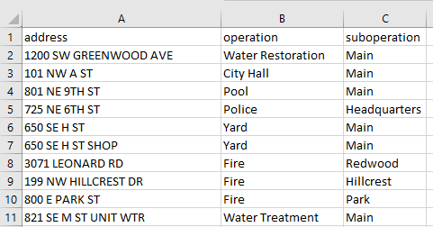

The address value must exactly match the service address appearing in the data files provided by Avista. In some cases (650 SE H ST) a variation of the address has appeared in the utility data files and so both variations are included in AvistaMaster.csv.

The operation and sub-operation values should match the expected names used by the city. If an operation does not have sub-operations, then the value “Main” should be used as the suboperation column value. [Note: Do NOT use the value “None” for sub-operation, as this value has special meaning to the Python data analysis programs].

If a city facility is no longer in use by the city or natural gas service is retired, it is critical that the entry in this file still remain. This is because historical data will still reference the facility. Generally, new entries will be added if a new building that has natural gas service is added to the city’s portfolio.

DieselConstants.csv

This file provides the factor used to determine the equivalent carbon-dioxide (CO2) emitted from each gallon of diesel fuel consumed. The value can be adjusted from year to year as formulations of diesel fuel change due to regulation or other reasons. If the value for a future year is not present in the file, the value of the latest year in the file will be used by default.

The file has two columns, the year and the emissions factor in kilograms of CO2 equivalent emitted per gallon of diesel fuel.

Source: <https://www.eia.gov/environment/emissions/co2_vol_mass.php>

Use the diesel and home heating fuel value. Note that there are 2.205 pounds per kilogram.

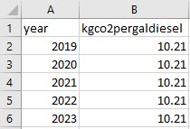

ElectricalConstants.csv

This file provides the factor used to determine the equivalent carbon-dioxide (CO2) emitted from each megawatt-hour of electricity consumed ( 1 megawatt-hour = 1,000 kilowatt-hours). The value can be adjusted from year to year as the mix of energy sources for utilities in the Northwest Region change. If the value for a future year is not present in the file, the value of the latest year in the file will be used by default.

The file has two columns, the year and the emissions factor in pounds of CO2 equivalent emitted per megawatt hour of electricity.

Source: <https://www.epa.gov/egrid/download-data>

The data can be obtained from the EPA eGRID (Emissions and Generation Resource Integrated Database) publication. This data is typically published each year in January. Check the Summary Data section of the referenced webpage. Use the value for the NWPP eGRID region. Use the CO2e value rather than the CO2 value, as the CO2e value incorporates methane and nitrous-oxide emissions as well as CO2.

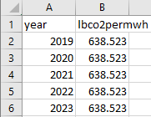

EmployeeCommuteConstants.csv

This file provides the values used to estimate the emissions contribution from commuting by city employees to work locations. The factors can be adjusted as the result of changes in the number of city employees, from the implementation of incentive or other programs that change commute behavior, or from adoption of electric vehicles by employees over time.

The file has six columns.

|  |  |  |
| --- | --- | --- |
| **Column** | **Definition** | **Note** |
| year | Year | The effective year of the parameter values on the row. |
| employees | Average number of employees who commute by private vehicle. | Do not include employees who take city vehicles home regularly, or employees who use alternative commute methods (walk, bike, public transit). |
| tripsperday | Average number of trips between home and work location per workday. | The value may be larger than 2 due to trips home for lunch. |
| milespertrip | Average miles between home and work location. |  |
| workdaysperyear | Average number of workdays per year. | The value is typically obtained from the human resources department as a standard value used for various purposes. |
| empvehmpg | Average miles per gallon fuel efficiency for employee vehicles. | An average value for personal passenger vehicles is typically used. |

The values appearing in the file as of the preparation of this guide were determined using a survey of city employees conducted in 2023 as part of the preparation of the Sustainable Energy Action Plan. The empvehmpg value was obtained from EPA GHG calculation tool.

If a value does not appear in the file for a future year, the latest row in the file will be used by default.

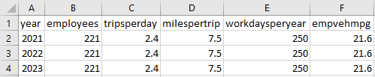

ForestSequestrationConstants.csv

This file provides the values used to estimate the sequestration of carbon-dioxide by trees located on city operated property, such as parks. The factors can be adjusted as the result of changes in the area of city operated property (such as by the creation of new parks) or in the proportion of land area which is forested (by planting new trees).

The file has three columns, the year, the city operated land area in square kilometers, and the ratio of land area which is forested.

The data is obtained from ArcGIS by the city’s GIS team.

If a value does not appear for a given year, the latest value in the file is used by default.

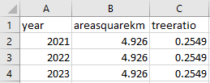

GasolineConstants.csv

This file provides the factor used to determine the equivalent carbon-dioxide (CO2) emitted from each gallon of gasoline consumed. The value can be adjusted from year to year as formulations of gasoline change due to regulation or other reasons. If the value for a future year is not present in the file, the value of the latest year in the file will be used by default.

The file has two columns, the year and the emissions factor in kilograms of CO2 equivalent emitted per gallon of gasoline.

Source: <https://www.eia.gov/environment/emissions/co2_vol_mass.php>

Use the motor gasoline value. Note that there are 2.205 pounds per kilogram.

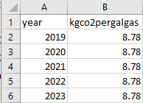

PacificPowerMaster.csv

This file provides the city operation and sub-operation associated with each service address at which an electrical meter is installed within city facilities. The following is an example of the contents:

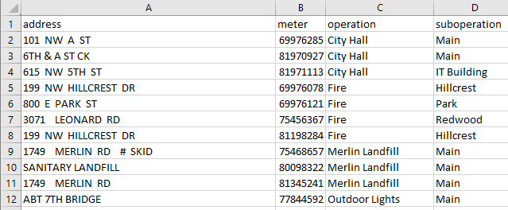

The meter number must exactly match the value appearing in the data files provided by Pacific Power. The address value is only used for documentation and reference purposes, and is **not** used by either the normalization or dashboard data generation scripts.

The operation and sub-operation values should match the expected names used by the city. If an operation does not have sub-operations, then the value “Main” should be used as the suboperation column value. [Note: Do NOT use the value “None” for sub-operation, as this value has special meaning to the Python data analysis programs].

If a city facility is no longer in use by the city or electricity service is retired, it is critical that the entry in this file still remain. This is because historical data will still reference the facility. Generally, new entries will be added if a new building that has electrical service is added to the city’s portfolio.

SolidWasteConstants.csv

This file includes the estimated emissions from solid waste, in metric tons of CO2 equivalent, for all city operations for each year. The value is calculated using the EPA WARM calculator or other means yet to be determined. This value is prorated across all city operations having solid waste disposal costs for each year, based on the total cost for each operation.

If a year does not have an entry in the file, the latest value is used by default.

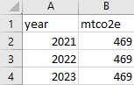

VehiclesMaster.csv

This file describes the vehicles in current or past operation by the city. It is used for the purposes of the dashboard to assign vehicles to city operations and sub-operations, and to identify the fuel type used for the vehicle in order to accurately determine the emissions value from fuel consumed.

Other columns in the file are used to further categorize vehicles by model year, category and purpose. While these columns are not currently used by the dashboard programs, it is recommended that the values be maintained for new vehicles to support future vehicle fleet analysis and planning.

The following is a sample of the file content:

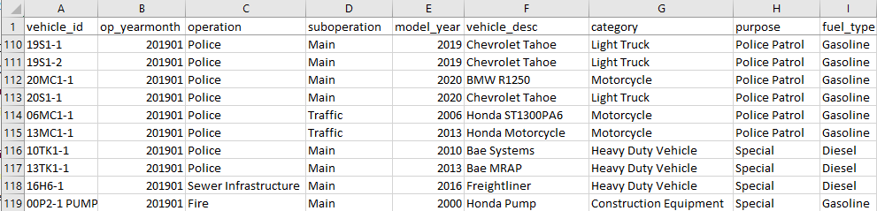

Each column in the file is described in the following table.

| **Column** | **Description** | **Notes** |
| --- | --- | --- |
| vehicle_id | The unique identifier of the vehicle. | Multiple rows may appear in the file for the same vehicle if it was assigned to different operations over time. |
| op_yearmonth | The starting year and month that the vehicle was assigned to the indicated operation and sub-operation. | If a vehicle is transferred from one city operation to another, the year and month that the new operation assignment is effective is shown. Use the yyyymm format, where yyyy is the year value and mm is the two-digit month number with leading zero required if the month number is less than 10.  “202307” = July 2023 |
| operation | The city operation that used the vehicle. |  |
| suboperation | The sub-operation within the operation that used the vehicle. | If there is no sub-operation for the associated operation, enter the value “Main” for the sub-operation. |
| model_year | The model year of the vehicle. |  |
| vehicle_desc | The description of the vehicle, typically the make and model. |  |
| category | The vehicle category as defined in the EPA GHG Emissions Calculator. | Values in use are:  Construction Equipment  Heavy Duty Vehicle  Light Truck  Motorcycle  Passenger Car  Utility and Recreational Equipment |
| purpose | The purpose of the vehicle. This value has been used in prioritizing conversion of vehicles to zero-emission (i.e. electric) vehicles. | Values in use are:  Construction  Fire Apparatus  General  Police Patrol  Special |
| fuel_type | The type of fuel that the vehicle uses. | Values are:  Diesel  Gasoline  Electricity |

The first row must be the header row and the order of the columns must be preserved as documented. Other than the first row, the rows may appear in any order and may be sorted to facilitate data maintenance. Suggested order is by vehicle_id and op_yearmonth, or by operation, sub-operation, vehicle_id, and op_yearmonth.

If a fuel event record is found that falls before the earliest op_yearmonth value for the vehicle, then the earliest records based on the op_yearmonth will be used by default.

If a vehicle is no longer used by the city, an entry for the vehicle must still appear in this file in order to correctly categorize and perform emissions calculations for historical data.

WaterRestorationConstants.csv

This file contains the parameters used to calculate emissions from the city Water Restoration Plant (WRP) due to treatment operations. The values were provided by the WRP staff using actual measurements.

The columns are the year, the average gas produced by the primary digester as measured in cubic feet per day, and the portion of methane (CH4) in the produced gas as measured. The portion is expressed as a decimal value rather than as a percentage (i.e. 0.60 instead of 60%).

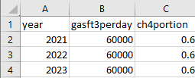

If a value is not found for a given year, the latest value from this file is used by default.